**TASK # 1 :Create an innovative web page by HTML and all the necessary tags defined in the document defining any latest trend or technology.**

**CODE:**

<!DOCTYPE html>

<head>

<title></title>

</head>

<body>

<h1 align="center">PYTHON PROGRAMMING LANGUAGE</h1>

<div>

<img style="margin-left:auto; margin-right:auto; width: 50%; display:block" src="V1.jpg">

<p>

Python is a programming language.

Python is an interpreted, high-level, general-purpose programming language. Created by Guido van Rossum and first released in 1991, Python's design philosophy emphasizes code readability with its notable use of significant whitespace. Its language constructs and object-oriented approach aim to help programmers write clear, logical code for small and large-scale projects.[28]

<h2>Syntax and symentics</h2>

<ol>

<li>indentation</li>

<li>statements and control flow</li>

<li>Expressions</li>

<li>Methods</li>

<li>Typing</li>

<li>Mathematics</li>

</ol>

<h2>Data types</h2>

<table border="1px">

<tr>

<th>type</th>

<th>description</th>

</tr>

<tr>

<td>bool</td>

<td>Boolean value</td>

</tr>

<tr>

<td>bytearray</td>

<td>Sequence of bytes</td>

</tr>

<tr>

<td>bytes</td>

<td>Sequence of bytes</td>

</tr>

<tr>

<td>dict</td>

<td>Associative array (or dictionary) of key and value pairs; can contain mixed types (keys and values), keys must be a hashable type </td>

</tr>

<tr>

<td>list</td>

<td>List, can contain mixed types </td>

</tr>

</table>

</p>

</div>

</body>

</html>

**OUTPUT:**

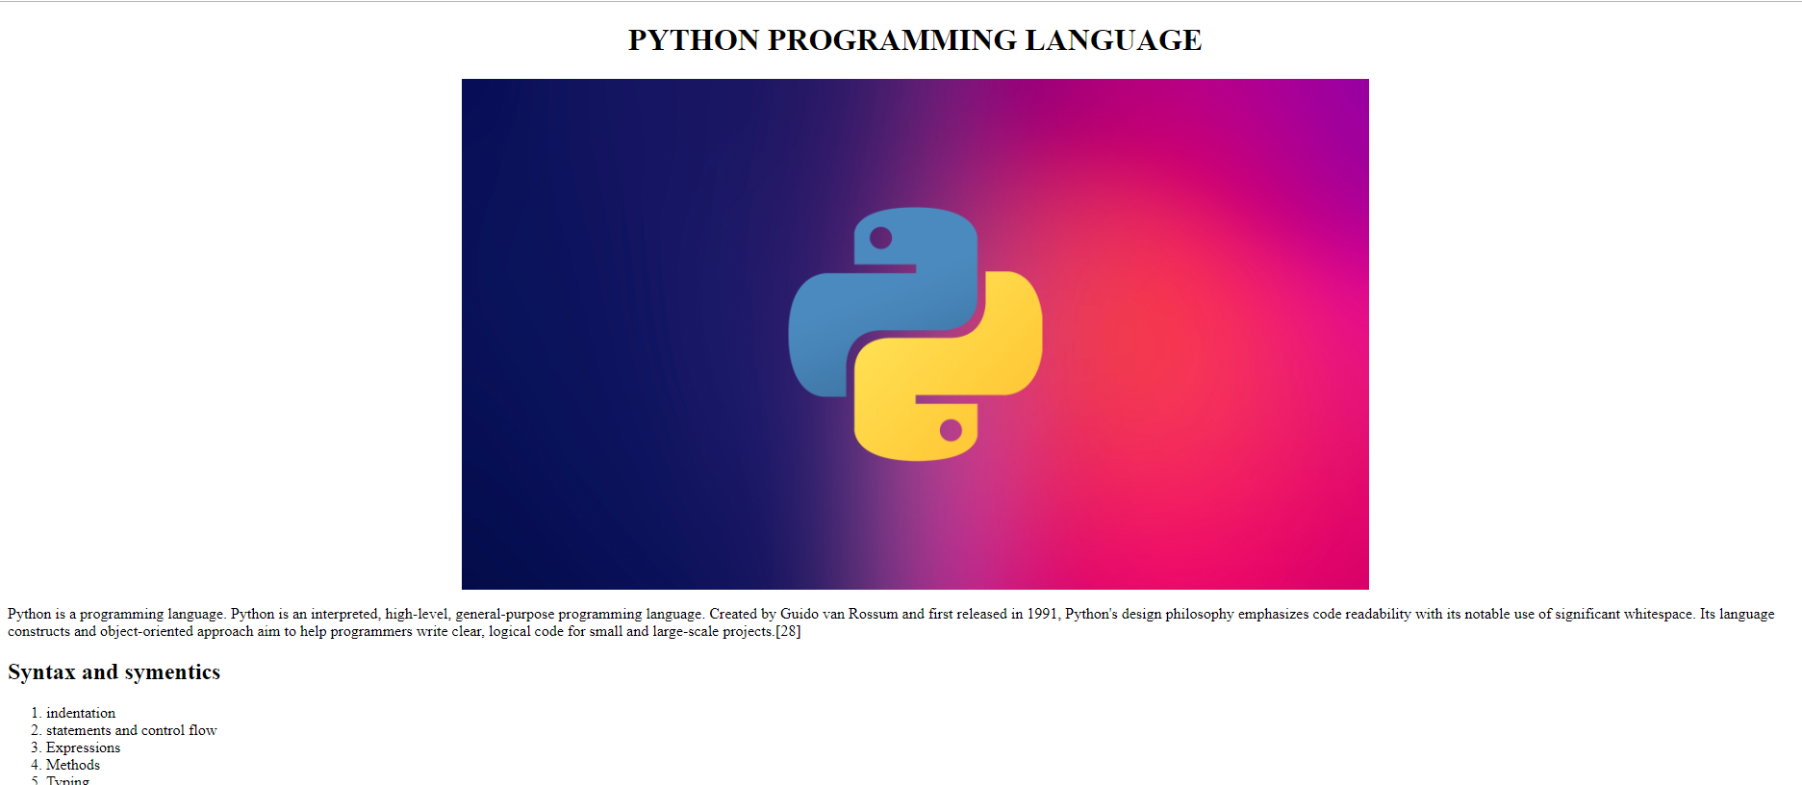

**TASK # 2 : Create test and validate an HTML document that describes an ordered list with the**

**following contents:the highest level should be the names of your parents, with your mother**

**first. Under each parent you must have a nested,ordered list of the brother and sisters of**

**your parents(your aunts and uncles) in order by age, eldest first. Each of the nested list in**

**turn must have nested lists of children of your aunts and uncles(your cousins)- under the**

**proper parents,ofcourse. Regardless of how many aunts , uncles and cousins you actually**

**have,there must be atleast three list items in each sublist below each of your parents and**

**below each of your aunts and uncles.**

**CODE:**

<!DOCTYPE html>

<head>

</head>

<body>

<h1 align="center">Nested Lists</h1>

<ol>

<li>Mother</li>

<ol>

<li>Sister - 50</li>

<ol>

<li>son - 26</li>

<li>son - 24</li>

<li>sister -21</li>

</ol>

<li>Brother - 45</li>

<ol>

<li>son - 20</li>

<li>sister - 19</li>

</ol>

<li>Sister - 42</li>

</ol>

<li>Father</li>

<ol>

<li>Brother - 40</li>

<ol>

<li>son - 18</li>

<li>sister -16</li>

</ol>

<li>Brother - 35</li>

<ol>

<li>son - 15</li>

<li>sister - 13</li>

</ol>

</ol>

</ol>

</body>

</html>

**OUTPUT:**

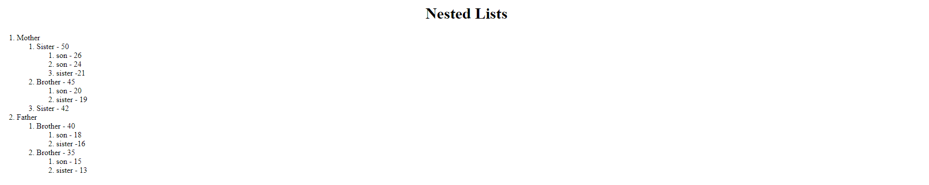

**TASK # 3:**

**Create an innovative web page by HTML and all the Semantic tags if possible**

<!DOCTYPE html>

<head>

</head>

<body>

<header>

<h1>This is the header</h1>

</header>

<nav>

<ul style="list-style-type: none;margin: 0;padding-left: 0">

<li class="navbar"><a class="navbar" href="#">News</a></li>

<li class="navbar"><a class="navbar " href="#">Sports</a></li>

<li class="navbar"><a class="navbar" href="#">Weather</a></li>

</ul>

</nav>

<section class="news-section">

<h2>News section</h2>

<article>

<h2>News Article</h2>

<p>

TEST 1

<br>

TEST 2

</p>

</article>

<article>

<h2>News Article</h2>

<p>

TEST 1

<br>

TEST 2

</p>

</article>

</section>

<footer>

<p> all rights reserved &copy;</p>

</footer>

</body>

</html>

**OUTPUT:**

